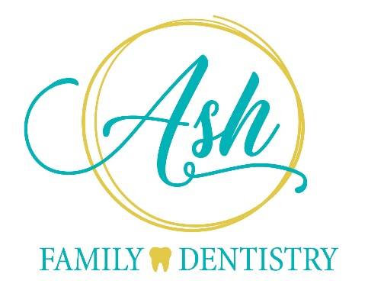

11/1/2023

Dear Valued Patient,
You are receiving this letter because you have a Metlife PDP or Metlife Federal dental insurance plan that we will not be in network with, in 2024. We will remain in network with Metlife PDP Plus and Metlife Federal VIP (FEDVIP).
The exact date we will be out of network is up to the insurance company so it is not known to us until it gets closer. As a courtesy, we are reaching out to you so you are aware of the changes. We have tried to negotiate reimbursement with Metlife, however, it has not worked out, therefore, we are changing our participation within the Metlife network.

What does this mean for you as a patient?
- We are still committed to providing dental care for your family. You are still welcome to continue your care at our office, and we will file your claims. You may have different co-pays than what you had when we were in network. Metlife would reimburse you your negotiated rate.
- Talk to your employer - You may be able to switch your employer plan to another dental insurance company or upgrade your current plan to Metlife PDP Plus (which will still be a network plan in our office). If your Metlife plan is a federal plan, you can switch to a GEHA high option plan or a Federal VIP plan. Contact your HR company about open enrollment options for the future. We are still in network with many other companies as well.
- You could use our in-house discount plan instead of your Metlife plan to have more control of your dental care decisions without insurance company restrictions.

Remember that good oral care is very important to overall health and that preventive care is always less costly than waiting until there is a problem. Feel free to contact our office if you need any assistance in understanding your insurance plan.

Sincerely,
Dr. Rajvi Sheladia, DDS
Ash Family Dentistry

